**Home work 1 (Codes)**

1. Write a NumPy code line(s) to get and print your numpy library version

Sol :

import numpy as np

np.version.version

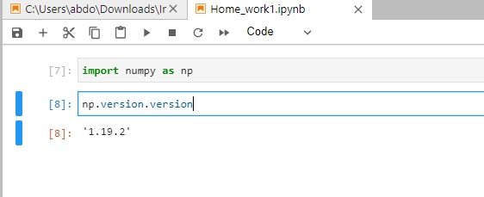

1. Write a NumPy code line(s) to get help on the “add” function.

Sol:

import numpy as np

print(np.info(np.add))

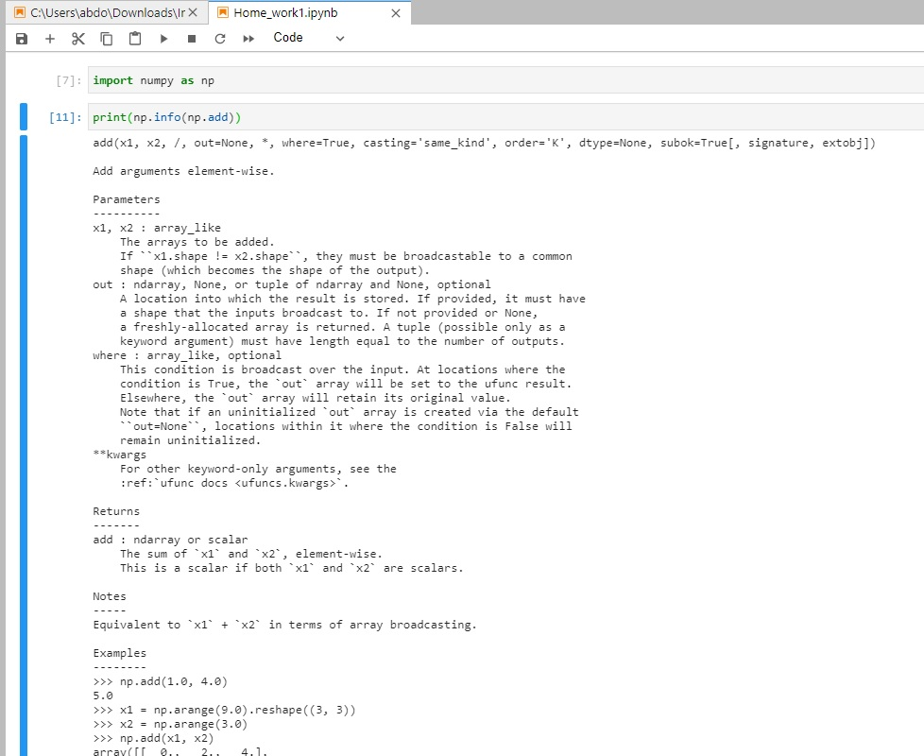

1. Write a NumPy code line(s) to test whether any of the elements of an input array is non-zero

Sol :

import numpy as np

a=np.array(list(map(int,input().split())))

print(np.any(a))

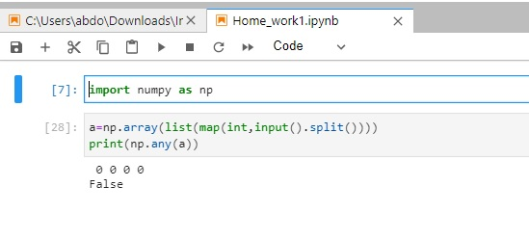

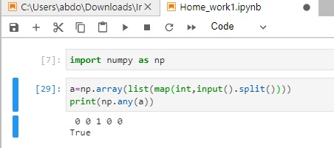

1. Write a NumPy code line(s) to compute the x and y coordinates for points on a sine curve and plot the points using matplotlib.

Sol:

import numpy as np

import matplotlib.pyplot as plt

x=np.arange(0,3*np.pi,0.1)

y=np.sin(x)

plt.plot(x, y)

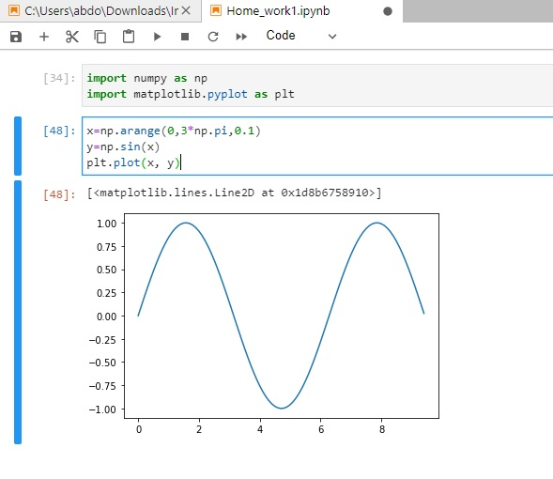

1. Write a NumPy code line(s) to add elements in a matrix. If an element in the matrix is 0, we will not add the element below this element (in red)

Sol:

import numpy as np

a=np.array([(1,1,0,2),(0,3,0,3),(1,0,4,4)])

b=a.T

r=b.reshape(-1)

sum_array=0

for i in range(len(r)):

if r[i-1]==0:

continue

sum_array +=r[i]

sum_array

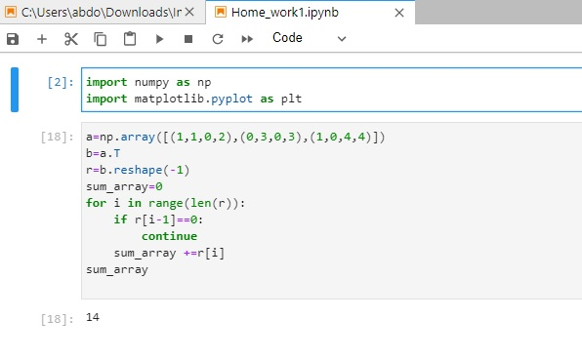

1. Write a NumPy code line(s) to extract all numbers which are less and greater than a specified integer in an input array

Sol:

import numpy as np

array=np.array(list(map(int,input().split())))

condition=array<5

np.extract(condition, array)

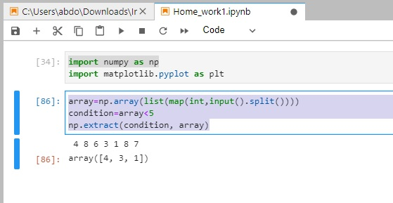

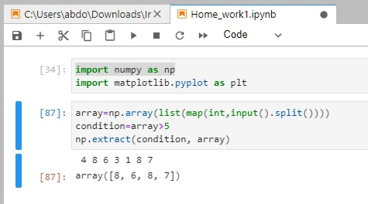

1. Write a NumPy code line(s) to find the missing (hint: undefined) data in an input array

Sol:

import numpy as np

array=np.array([np.log(-1.),1,5,np.log(-1.)])

b=np.isnan(array)

c=np.extract(b, array)

print(c)

